**Bring It On**

1. Install Jenkins

2. Create the task which will perform the following:

* Clone [the project](https://github.com/vitalliuss/helloci" \t "[object Object])
* Launch tests from the project in Java directory with the help of mvn test goal

3. Set up build triggers:

* 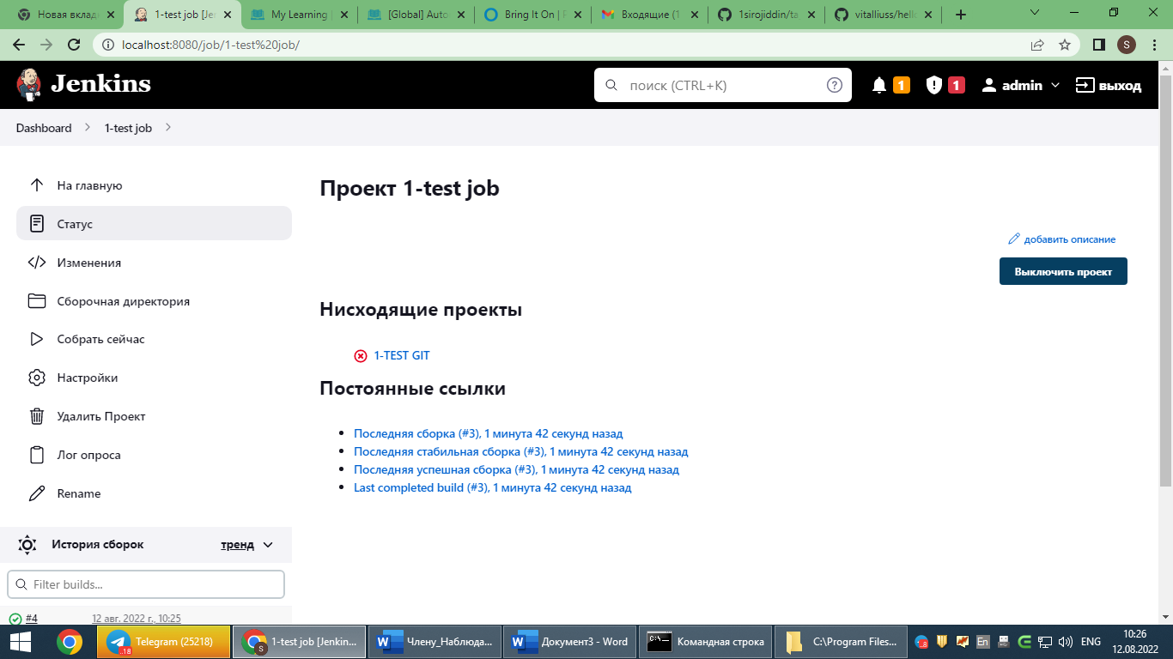Launch tests not later than 5 minutes after committing in git

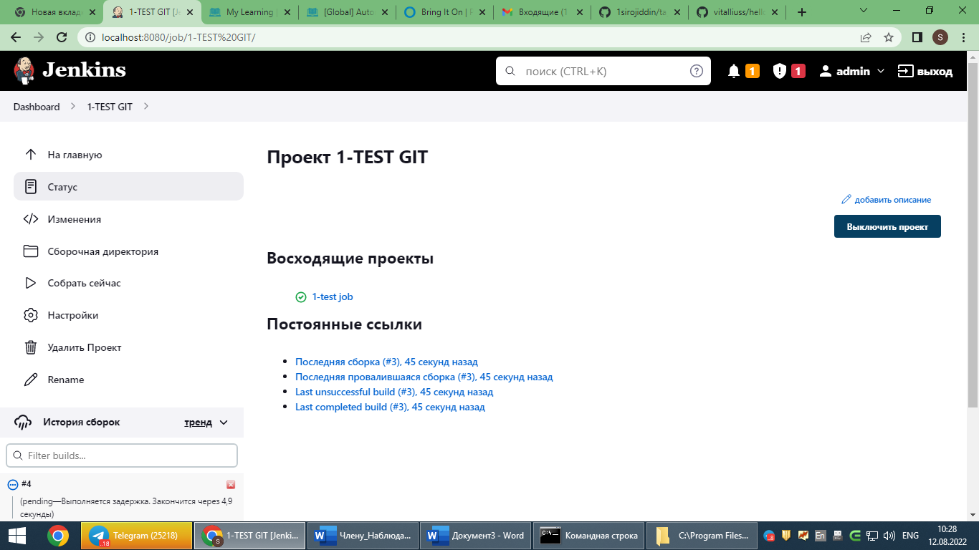

* 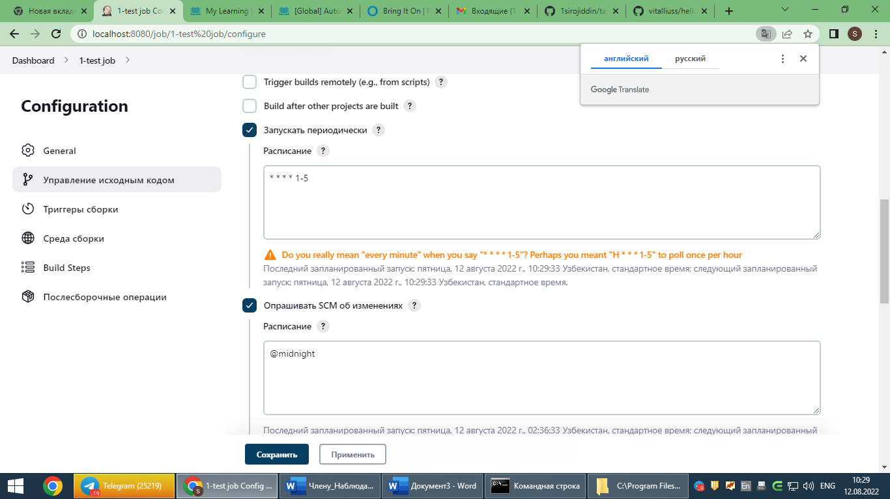Every workday at midnight